**What Parents Need to Know about Enterovirus D68**

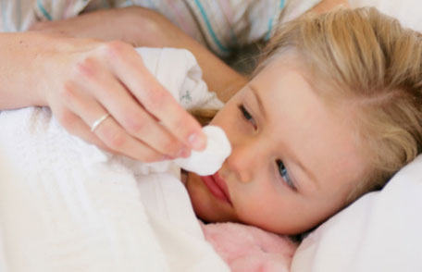**Every year, millions of children in the United States catch enteroviruses that can cause coughing, sneezing, and fever. In 2014, the enterovirus that most commonly caused respiratory illness in children across the country was enterovirus D68 (EV-D68). Take basic steps to keep your child from getting and spreading EV-D68.**

Infections with enteroviruses are common in the United States during summer and fall. In August 2014, a couple of states started seeing more children in hospitals with severe respiratory illness caused by EV-D68. In the months following this discovery, CDC and states did more testing and found that EV-D68 was making people sick in almost all states. Most of the cases were among children, many who had asthma or a history of wheezing. EV-D68 is not new, but it wasn’t as common in the past as it was in 2014. While 2014 was a big year for EV-D68 infections, CDC can’t predict whether EV-D68 will be a common type of enterovirus to cause sickness in future seasons. That’s because a mix of different enteroviruses types circulates every year, and different types can be common in different years.

**Children are at higher risk for EV-D68**

Infants, children, and teenagers are at higher risk than adults for getting infected and sick with enteroviruses like EV-D68. That's because they have not been exposed to these types of viruses before, and they do not yet have immunity (protection) built up to fight the disease. If your child has asthma, he or she may be at greater risk for severe respiratory illness from EV-D68.

**Know the signs of symptoms of EV-D68**

EV-D68 can cause mild to severe respiratory illness.

* Mild symptoms may include fever, runny nose, sneezing, cough, and body and muscle aches.
* Severe symptoms may include wheezing and difficulty breathing.

Call your child's doctor if he or she is having difficulty breathing, if you feel you are unable to control symptoms, or if symptoms are getting worse. If your child develops severe illness, he or she may need to be hospitalized.



Washing hands correctly is the most important thing you can do to stay healthy.

Follow these steps to protect your children from EV-D68 & other viruses.

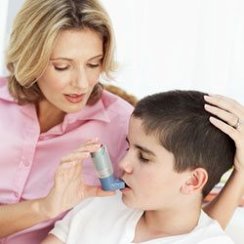

Children with asthma are particularly at risk for severe symptoms from EV-D68 infection.

**Help protect your family from EV-D68**

To help avoid catching and spreading EV-D68, parents and children should always follow basic steps to stay healthy.

* Wash hands often with soap and water for 20 seconds. Washing hands correctly is the most important thing you can do to stay healthy. See [Handwashing: Clean Hands Save Lives](http://www.cdc.gov/handwashing/index.html).
* Avoid touching eyes, nose and mouth with unwashed hands.
* Avoid close contact, such as kissing, hugging, and sharing cups or eating utensils, with people who are sick.
* Cover your coughs and sneezes with a tissue or shirt sleeve, not your hands.
* Clean and disinfect frequently touched surfaces, such as toys and doorknobs, especially if someone is sick.
* Stay home when you are sick and keep sick children out of school.

**EV-D68 treatment**

There is no specific treatment for EV-D68. Talk to your child's doctor about the best way to control his or her symptoms.

**If your child has asthma**

Children with asthma are particularly at risk for severe symptoms from EV-D68 infection. Therefore, if your child has asthma, take some steps to prepare in case he or she catches EV-D68. CDC recommends you do the following to help maintain control of your child's asthma during enterovirus season, which occurs each year in the U.S. during summer and fall:

* Discuss and update your child's [asthma action plan](http://www.cdc.gov/asthma/actionplan.html) with his or her doctor.
* Make sure your child takes his or her prescribed asthma medications as directed, especially long-term control medication(s).
* Make sure your child knows to keep asthma reliever medication with him or her or has access to it at all times.
* Get your child a flu vaccine, since flu and other respiratory infections can trigger an asthma attack. See [Vaccination: Who Should Do It, Who Should Not and Who Should Take Precautions](http://www.cdc.gov/flu/protect/whoshouldvax.htm)
* If your child develops new or worsening asthma symptoms, follow the steps of his or her asthma action plan. If symptoms do not go away, call your child's doctor right away.
* Make sure caregiver(s) and/or teacher(s) are aware of the child's condition, and that they know how to help if the child experiences any symptoms related to asthma.
* Call your child's doctor if he or she is having difficulty breathing, if you feel you are unable to control symptoms, or if symptoms are getting worse.